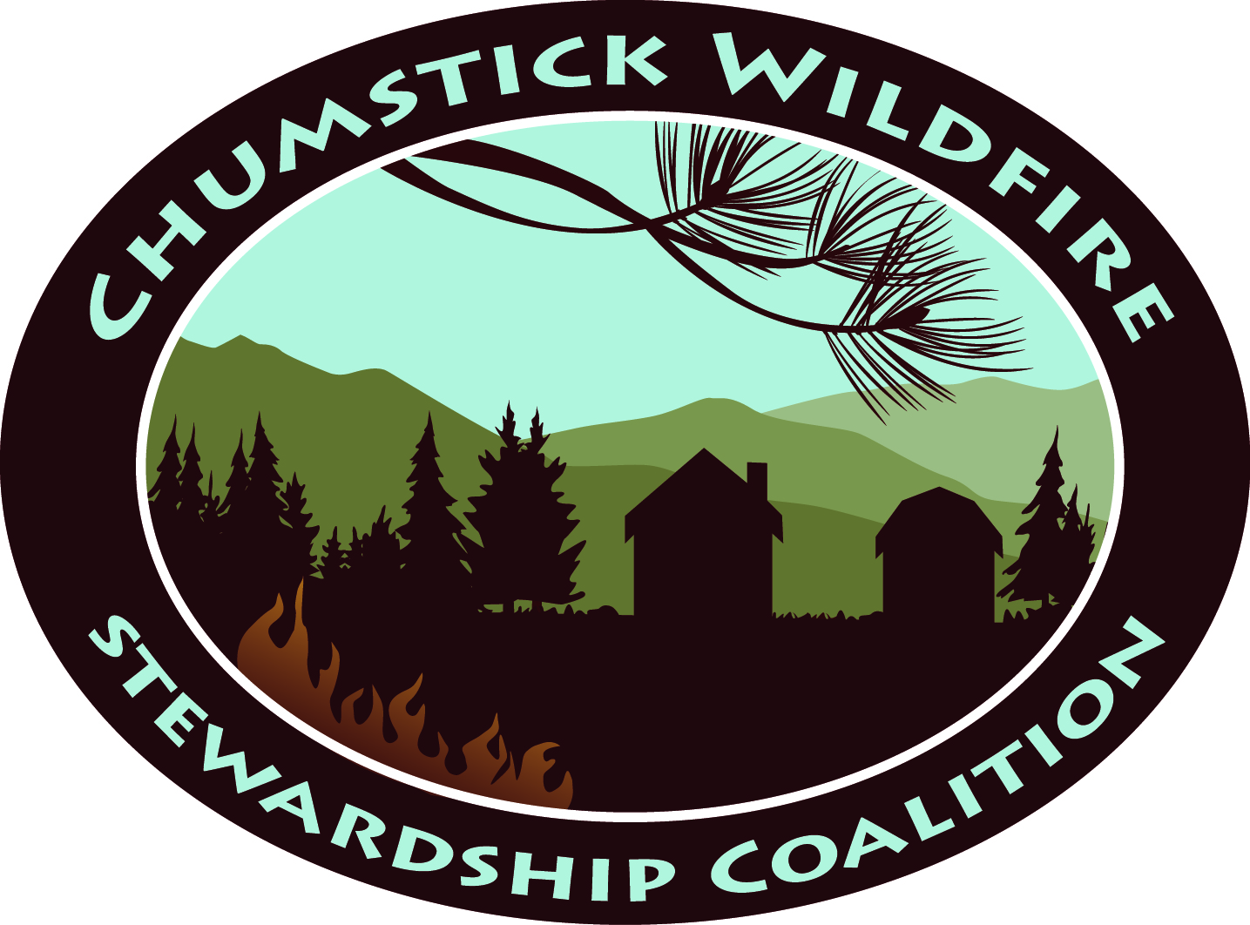  Chumstick Wildfire Stewardship Coalition |  | Date: July 1, 2021
 |  | Time: 6:00 p.m.
 |  | Location: Zoom or Leavenworth Fire Hall
Meeting called by: | John Callahan, CWSC Steering Committee Chair
Type of Meeting: | CWSC Steering Committee Meeting

AGENDA | PRESENTER
- Welcome and Call to Order  - Review and approve May 2021 SC Meeting minutes. | John
- 123 Program progress:  - 16 interested now  - 2021 Building Forest Partnerships Proposal:  - Award date pushed out  - Ember House  - Chumstick to Lower Peshastin: Today’s meeting  - Water tanks: DNR and USDA Funding sources  - Building Forest Partnerships grant complete as of June 30, 2021  - Washington Fire Adapted Communities grant complete as of July 15, 2021  - Financial Report | Corrine and Members
- Contractors  - Barbara Carrillo: Farmer’s Market update  - Fallon Technology: Website is live! Walk through | Corrine/ Barbara
- New business: (5 minutes or less each please)  - Chelan County Fire District 3  - City of Leavenworth  - Chelan County | Open
- Next meeting | John
- Adjourn meeting | John

